**YUTZY WOODWORKING**

Website: <https://www.urbancollectionsohiousa.com/>

#01

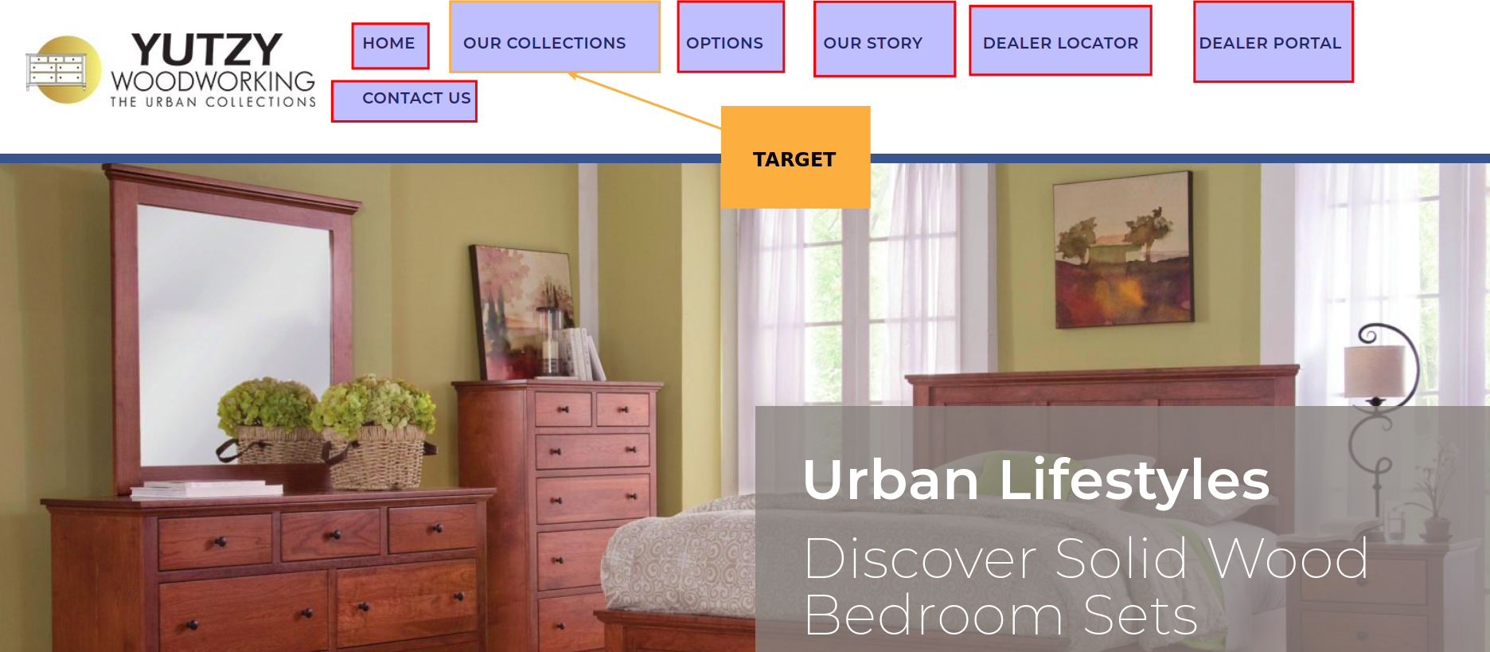

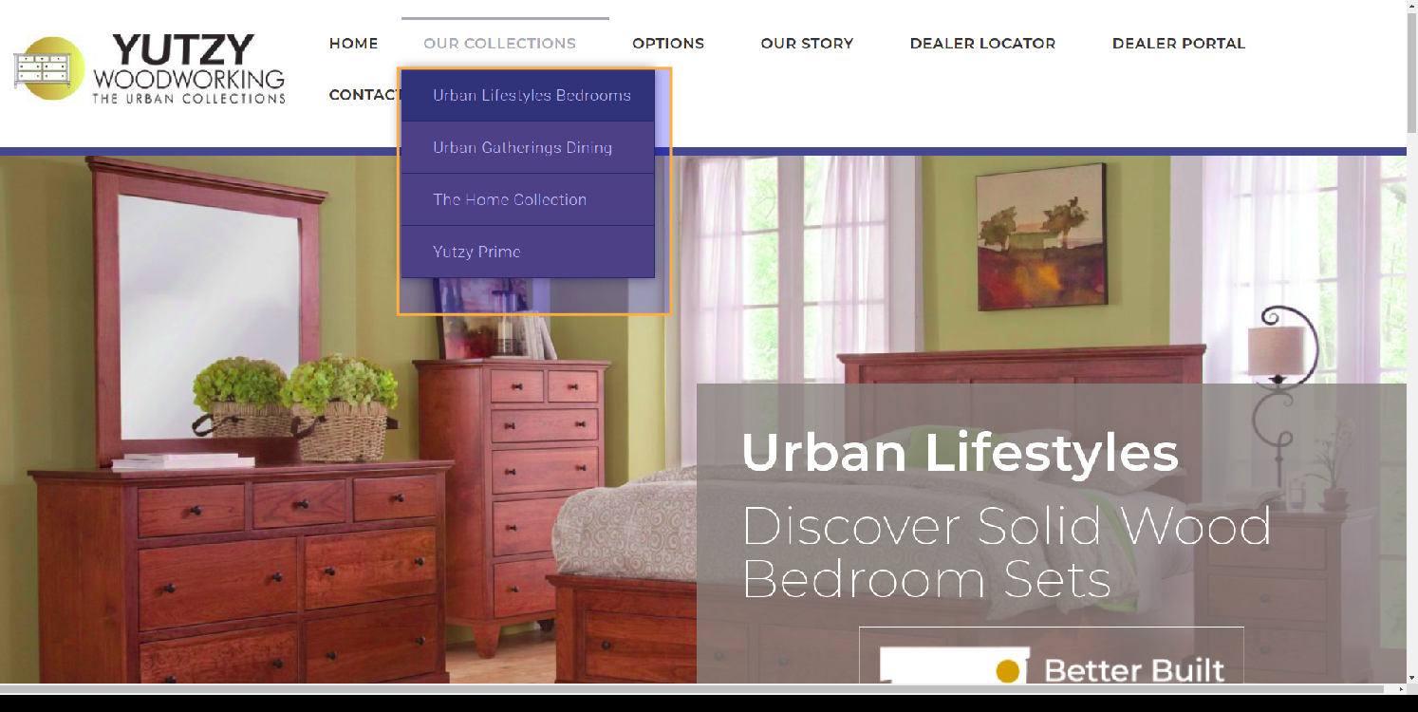

Response :

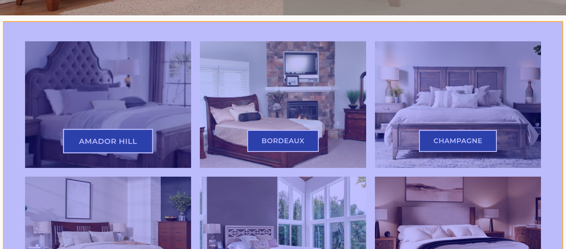

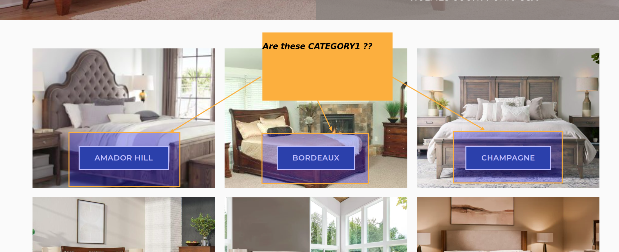

Response :

Do we need the description at the bottom of the collections page?  
<https://www.urbancollectionsohiousa.com/urban-lifestyles-bedrooms/>

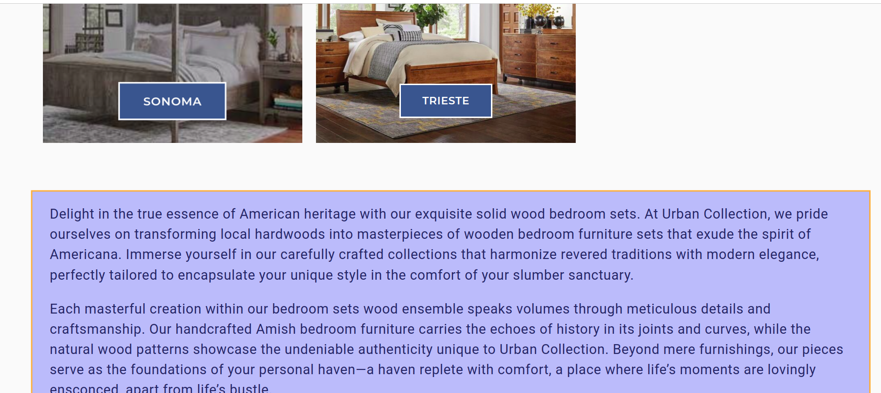

Response:

When we click on a collection:  
  
<https://www.urbancollectionsohiousa.com/amador-hill-bedroom/>

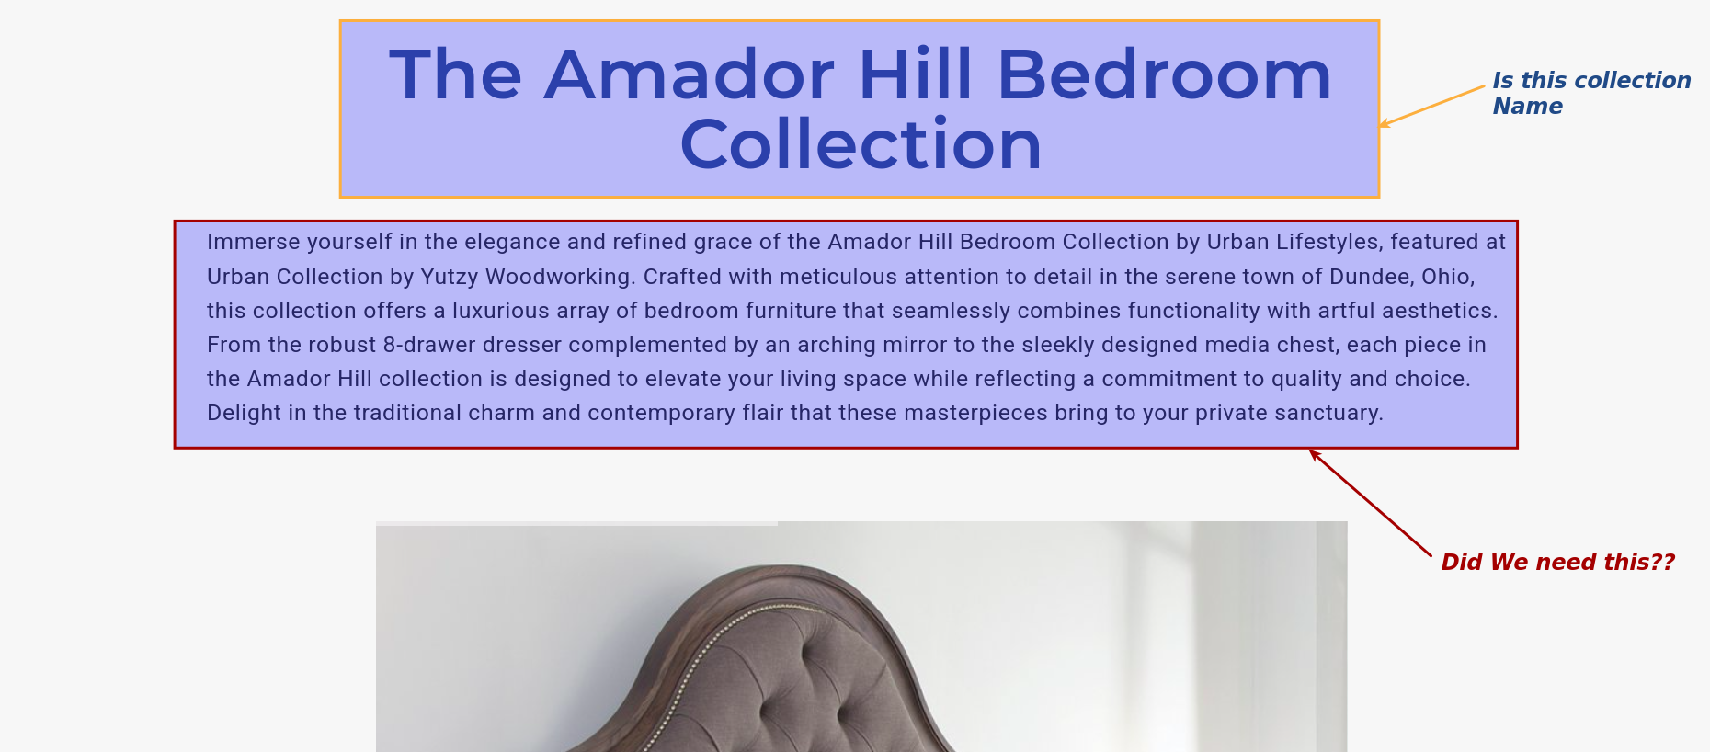

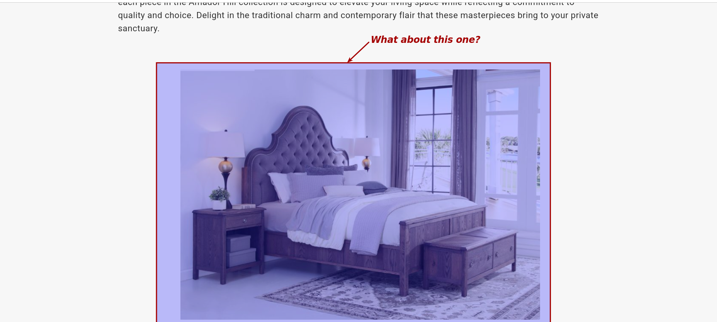

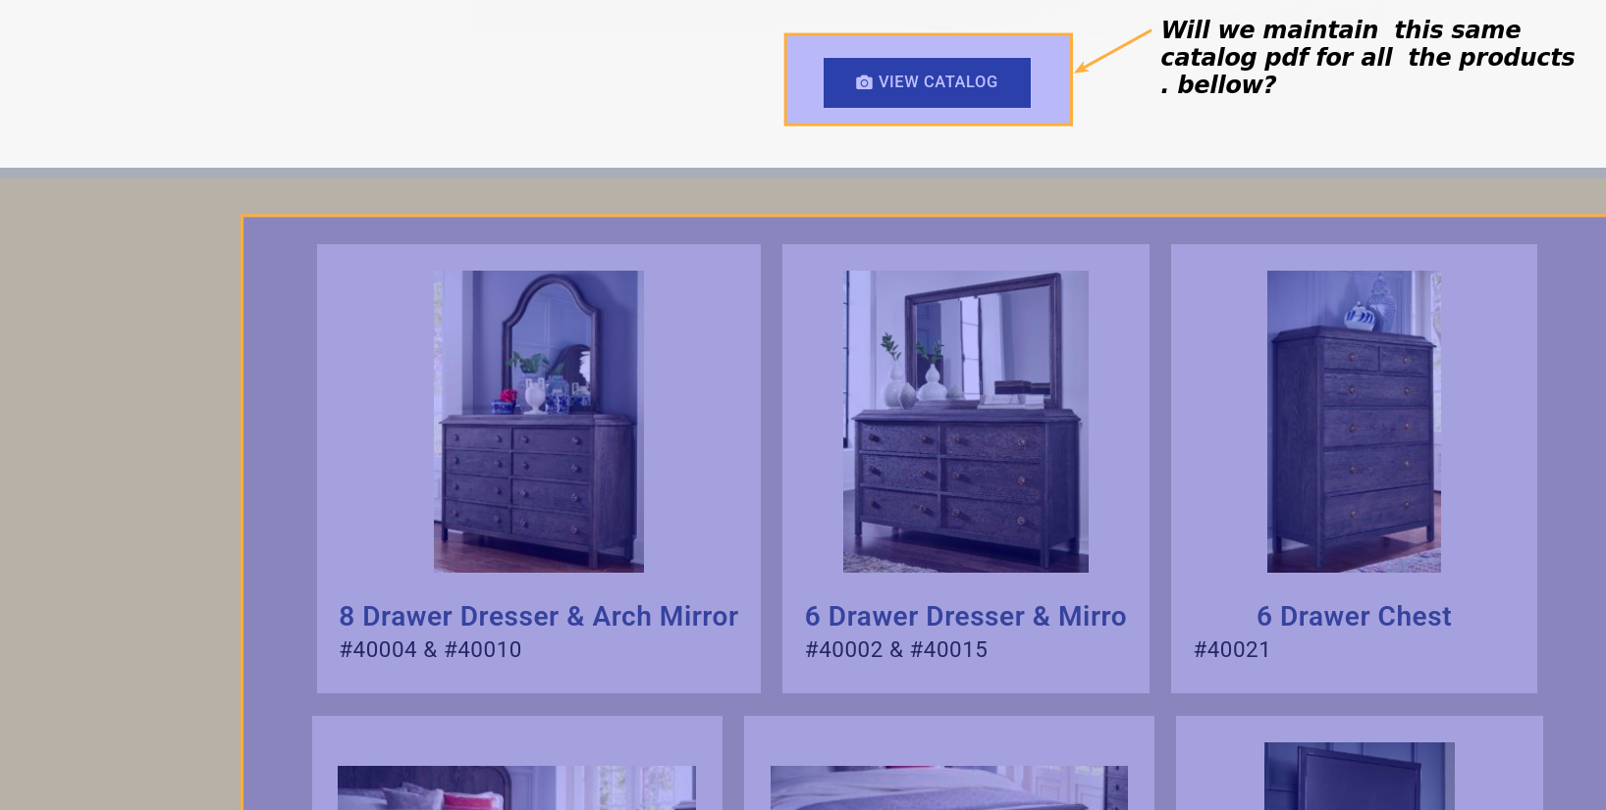

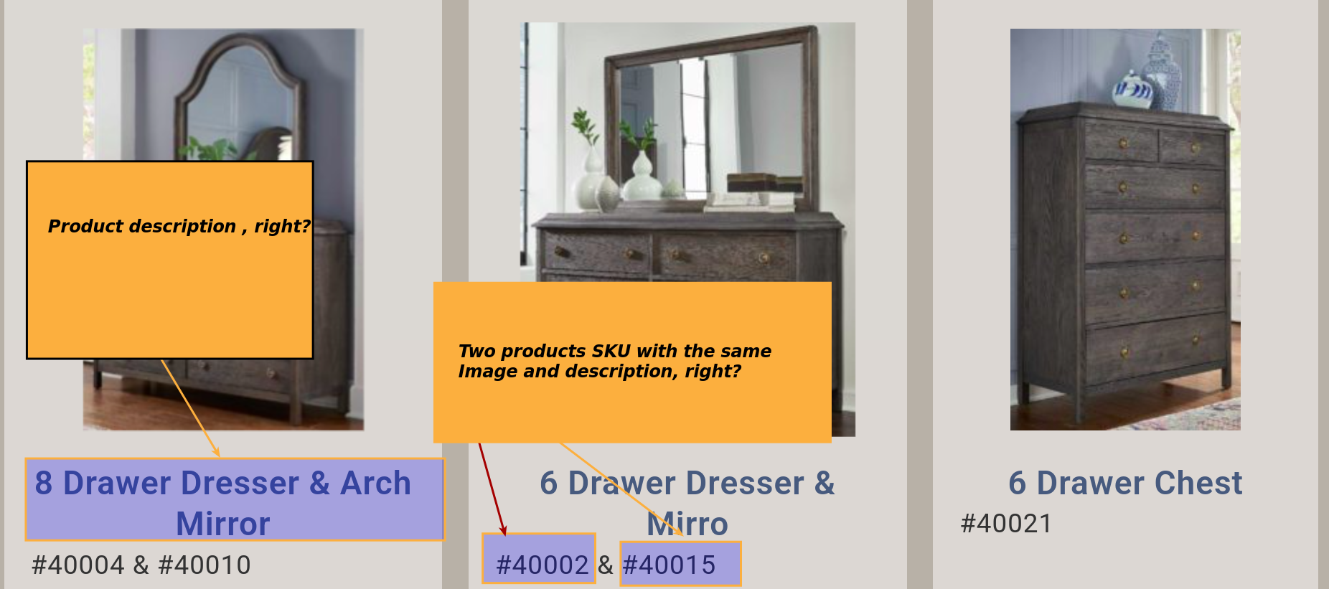

Response :

For this case : <https://www.urbancollectionsohiousa.com/jamestown-collection/>

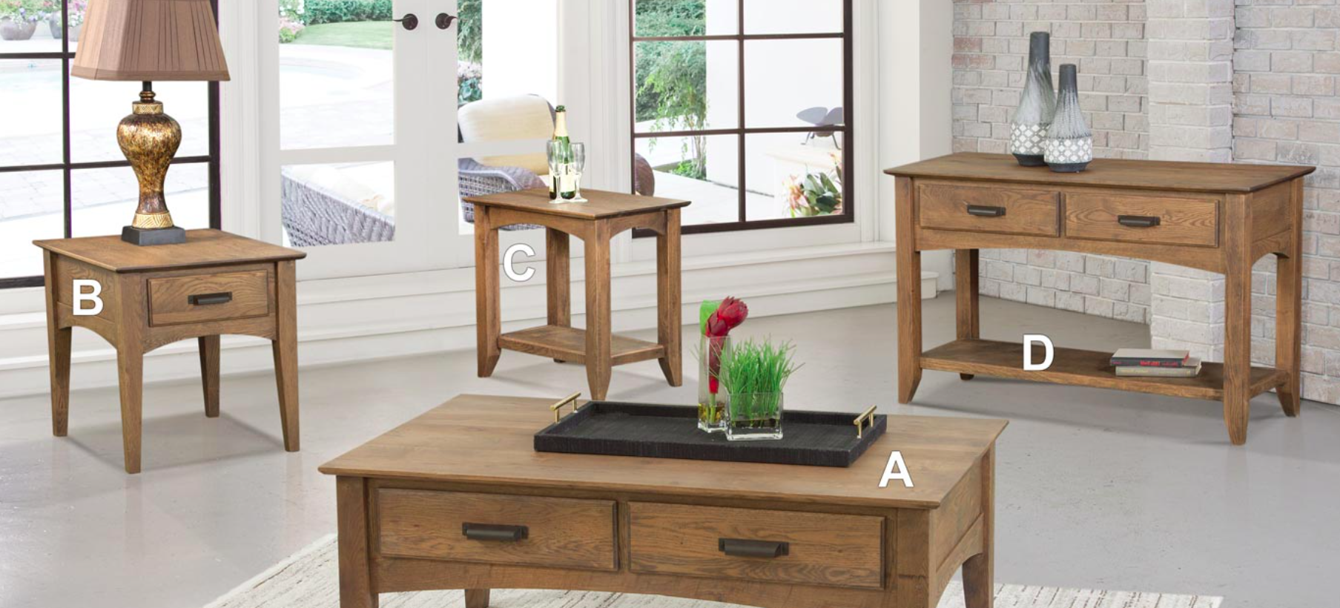

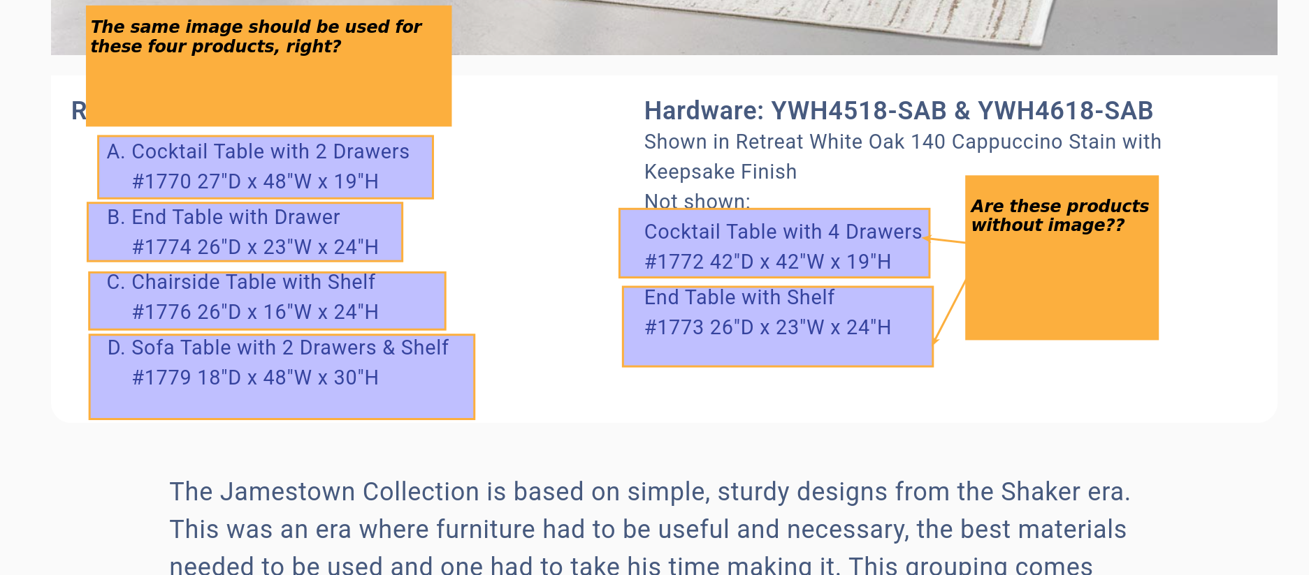

Response :

For this case: <https://www.urbancollectionsohiousa.com/cross-trestle-dining-2/>

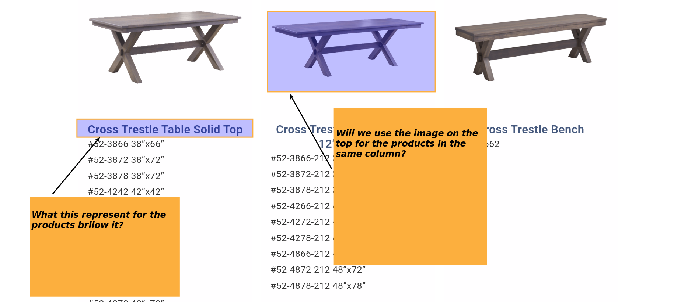:

Response :